Visual-Based Risk Communication Strategies for Lumpy Skin Disease (LSD) Prevention Among Smallholder Cattle Farmers

Rosa Zulfikhar, S.Sn., M.IKom1*, Nafisya Tamara2, Putri Pramudyaningrum3, Koleta
Lesek4, Najib Ali5, Naufal Destu6

¹⁻⁶ Department of Livestock Extension and Animal Welfare, Politeknik Pembangunan Pertanian Yogyakarta Magelang, Indonesia
*Corresponding Author Email: rosazulfikhar@gmail.com

ABSTRACT

Lumpy Skin Disease (LSD) poses a significant biosecurity threat to smallholder livestock systems, where traditional herd management practices often delay early detection and response. This study evaluates the development and impact of a visual-based risk communication strategy designed to enhance disease literacy and biosecurity adoption among smallholder cattle farmers in Krogowanan Village, Sawangan District, Magelang Regency. Utilizing a Participatory Rural Appraisal (PRA) framework combined with Urgency, Seriousness, and Growth (USG) problem prioritization across 12 active farmer groups, the intervention translated complex veterinary epidemiological concepts into clear visual media delivered via structured Microsoft PowerPoint modules. Results demonstrate that interactive visual tools significantly outperform conventional oral-only extension methods, improving clinical symptom recognition, accelerating reporting intentions, and facilitating the adoption of preventive sanitation routines.

Keywords: Animal Welfare, Lumpy Skin Disease, Participatory Rural Appraisal, Risk Communication, Visual Extension Media

1. INTRODUCTION
Smallholder livestock production is an integral component of rural agrarian economies in developing regions, providing household income, food security, and organic inputs for crop production. However, smallholder systems frequently operate under traditional management paradigms characterized by informal biosecurity measures and limited access to real-time veterinary expertise. This structural vulnerability exposes smallholders to severe economic shocks during outbreaks of exotic vector-borne epizootics, such as Lumpy Skin Disease (LSD).
LSD is a poxviral infection affecting cattle and buffaloes, characterized by nodular skin lesions, fever, and reduced productivity. In highland agro-ecological zones—such as Sawangan District, Magelang Regency (501–700 meters above sea level)—moderate temperatures and humid microclimates facilitate vector proliferation, increasing the probability of disease transmission. Despite the availability of preventive protocols, effective disease mitigation is heavily contingent upon the rapid detection and immediate isolation of infected animals by smallholder farmers.
Conventional agricultural extension models in developing nations have historically relied on abstract verbal communication or text-dense printed materials. These traditional communication channels often create cognitive barriers for farmers who possess varying levels of formal education. Risk communication theory suggests that visual tools—such as real-world clinical photography, infographics, and structured presentation slides—can bridge these gaps by reducing cognitive load and enhancing information retention.
This research examines the design, delivery, and field evaluation of a visual-based risk communication strategy tailored for LSD prevention in Krogowanan Village. By integrating Participatory Rural Appraisal (PRA) diagnostic tools with targeted visual extension media, this study aims to assess how visually supported advisory services influence smallholder understanding of disease risks and willingness to adopt preventive biosecurity measures.

2. LITERATURE REVIEW
2.1 Risk Communication in Veterinary Extension
Risk communication in agricultural systems serves as a vital bridge between scientific knowledge and community-level action. Effective risk communication must address not only the technical facts of a disease but also the socio-cultural context of the target audience. In veterinary health, delayed risk reporting directly increases outbreak severity; thus, extension messaging must prioritize clarity, immediate applicability, and actionable guidance.
2.2 Visual Media and Dual-Coding Theory
According to Paivio's Dual-Coding Theory, human cognition processes visual and verbal information through separate, parallel channels. Combining high-resolution clinical imagery with concise text during extension sessions creates dual cognitive traces, substantially improving recall and recognition. In rural extension settings, visual media eliminate ambiguities associated with technical jargon, allowing livestock producers to accurately identify early clinical signs such as nodular skin lesions and fever signs.
2.3 Participatory Rural Appraisal (PRA) in Problem Identification
Participatory frameworks are essential for ensuring that extension interventions address the authentic, self-identified needs of rural communities. PRA methodologies enable farmers to collaboratively analyze local agro-ecosystems, evaluate institutional relationships, and prioritize production constraints. Utilizing PRA prior to designing extension interventions ensures that risk communication tools are contextually grounded and culturally appropriate.

3. RESEARCH METHODOLOGY
3.1 Study Area and Duration
The field investigation was conducted in Krogowanan Village, Sawangan District, Magelang Regency, Central Java. Fieldwork spanned a 30-day period from June 22 to July 21, 2026, operating in close coordination with the Sawangan Agricultural Extension Center (BPP Sawangan).
3.2 Participatory Rural Appraisal (PRA) Framework
To establish baseline agro-ecological and socio-economic profiles, five core PRA instruments were implemented across 12 active farmer groups (kelompok tani):
Resource Mapping : Mapping spatial land-use patterns, water resources, and livestock distribution.
Seasonal Calendar : Documenting seasonal planting, harvesting, disease prevalence, and climate variations.
Transect Walks : Direct observational mapping of soil types, topographies, and farming practices from lowland to highland zones.
Venn Diagramming : Assessing institutional relationships between farmer groups, extension agents (PPL), commercial input suppliers, and local administration.
Farming Pattern Analysis: Evaluating cropping sequences and livestock integration practices.
3.3 Problem Prioritization via USG Matrix
Identified agricultural and livestock management problems were prioritized using the Urgency, Seriousness, and Growth (USG) scoring methodology:
Urgency (U): How time-critical the resolution of the problem is.
Seriousness (S): The potential severity of economic or environmental impact.
Growth (G): The likelihood of the issue escalating if unaddressed.
3.4 Interventional Design and Media Delivery
Based on USG scoring, an intervention focused on "Lumpy Skin Disease (LSD) Prevention and Early Detection" was selected. The communication material was structured into a visual Microsoft PowerPoint presentation consisting of:
High-definition clinical photographs showing early vs. advanced LSD lesions.
Graphical illustrations of vector transmission cycles (flies, mosquitoes, ticks).
Step-by-step visual guides for barn sanitation, vector control, and isolation protocols.
Emergency reporting flowcharts linking farmers directly to BPP extension personnel.

4. RESULTS AND DISCUSSION
4.1 Agro-Ecological and Livestock Profile
Krogowanan Village covers an area of 302.28 hectares across 12 hamlets, populated by 3,826 inhabitants whose primary livelihood is agriculture. Located at an altitude of 501–700 meters above sea level with average temperatures ranging between ${22}^{∘}\text{C}$ and ${32}^{∘}\text{C}$, the dominant soil types are fertile Latosol and volcanic Alluvial derived from Mount Merapi.
Parameter | Village Characteristics
Total Area | 302.284 hectares
Paddy Fields | 148 hectares
Dry Land / Yards | 98 hectares
Topography | Gently sloping highland (501–700 m ASL)
Dominant Crops | Rice, maize, chili, mustard green, yardlong bean
Livestock Population | Beef cattle, sheep, goats, poultry (backyard scale)
Institutional Framework | 12 active farmer groups (kelompok tani)
4.2 Participatory Diagnostic Findings
The PRA diagnostic revealed that while crop management was relatively advanced, cattle production was primarily treated as a secondary economic activity or savings mechanism rather than an intensive enterprise.

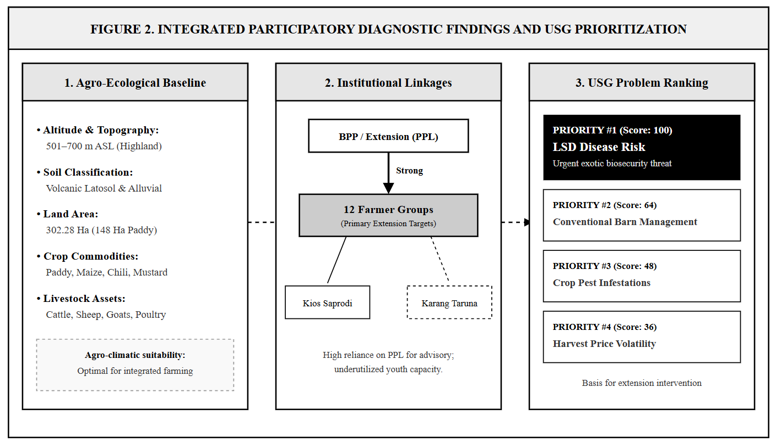

Venn diagramming highlighted a strong, trusted relationship between farmer groups and Extension Agents (PPL). However, interaction with animal health services was largely reactive—occurring only after severe disease manifestations were observed.
4.3 USG Matrix Evaluation
Through Focus Group Discussions (FGDs) with group leaders, key farming constraints were scored to determine the most critical intervention point:
Identified Issue | Urgency  (U) | Seriousness  (S) | Growth  (G) | Total (U×S×G) | Rank
Risk of Exotic Cattle Diseases (LSD) | 5 | 5 | 4 | 100 | 1
Conventional Barn Sanitation & Management | 4 | 4 | 4 | 64 | 2
Crop Pest Infestations (Chili/Paddy) | 4 | 4 | 3 | 48 | 3
Market Price Volatility During Harvest | 3 | 4 | 3 | 36 | 4
Infrastructure Deficits in Farm Roads | 3 | 3 | 2 | 18 | 5
4.4 Impact of Visual Risk Communication
The introduction of the visual PowerPoint intervention produced immediate shifts in farmer engagement and comprehension compared to conventional non-visual talks:

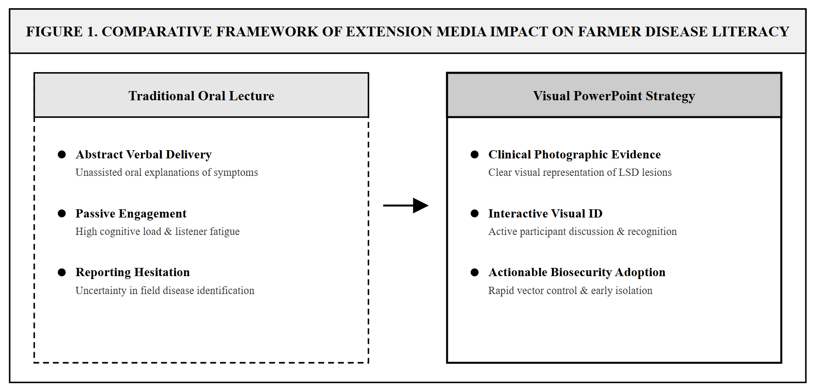
Farmers reported that viewing actual photographs of early-stage LSD nodules removed ambiguity regarding how the disease manifests in real field conditions. Comparative evaluation showed that visual media significantly enhanced the group's capacity to recognize vector control procedures (e.g., stagnant water elimination and barn spraying) as practical, achievable tasks rather than complex theoretical burdens.

5. CONCLUSION AND RECOMMENDATIONS
This study demonstrates that visual risk communication is a highly effective tool for advancing disease literacy among smallholder cattle producers. By deploying targeted visual media during participatory extension sessions, complex biosecurity guidelines were successfully transformed into actionable community practices.
Policy Recommendations:
- Institutionalization of Visual Assets: Agricultural Extension Centers (BPP) should establish standardized visual repositories for high-consequence livestock diseases.
- Integration with Digital Platforms: Visual extension modules should be adapted into mobile-friendly formats (e.g., messaging apps) to support continuous peer-to-peer learning.
- Capacity Building: Extension officers should receive continuous training in instructional design and visual communication techniques.

REFERENCES
- Badan Penyuluhan dan Pengembangan Sumber Daya Manusia Pertanian (BPPSDMP). (2019). Pedoman Penyusunan Rencana Kerja Tahunan Penyuluh Pertanian. Jakarta: Kementerian Pertanian Republik Indonesia.
- Bahua, M. I. (2021). Penyuluhan dan Pemberdayaan Peternak. Gorontalo: Ideas Publishing.
- FAO. (2021). Lumpy Skin Disease: A field manual for veterinarians and extension officers. Rome: Food and Agriculture Organization of the United Nations.
- Kementerian Pertanian Republik Indonesia. (2016). Peraturan Menteri Pertanian Nomor 47/Permentan/SM.010/9/2016 tentang Pedoman Penyusunan Programa Penyuluhan Pertanian. Jakarta: Kementerian Pertanian RI.
- Notoatmodjo, S. (2014). Promosi Kesehatan dan Perilaku Kesehatan. Jakarta: Rineka Cipta.
- Paivio, A. (2013). Mind and Its Evolution: A Dual Coding Theoretical Approach. New York: Routledge.
- Rahmawati, D., Nugroho, A., & Prasetyo, H. (2024). Transformasi Digital dalam Penyuluhan Pertanian dan Peternakan. Jurnal Penyuluhan Pembangunan Pertanian, 19(1), 45-58.
- Tufte, E. R. (2001). The Visual Display of Quantitative Information (2nd ed.). Cheshire: Graphics Press.
- World Organisation for Animal Health (WOAH). (2023). Terrestrial Manual: Lumpy Skin Disease. Paris: WOAH.
- Zulfikhar, R., Tamara, N., Pramudyaningrum, P., Lesek, K., Ali, N., & Destu, N. (2026). Perencanaan Penyuluhan Pertanian dan Identifikasi Potensi Wilayah di Desa Krogowanan, Kecamatan Sawangan. Laporan Praktik Kerja Lapangan I, Politeknik Pembangunan Pertanian Yogyakarta Magelang.

